Palmetto Bengals

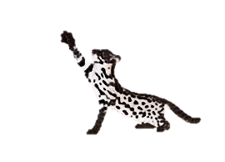
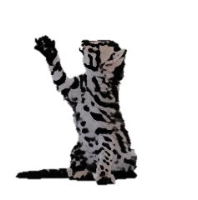

Early Generation Bengal Success Guide

Getting off to the right start!

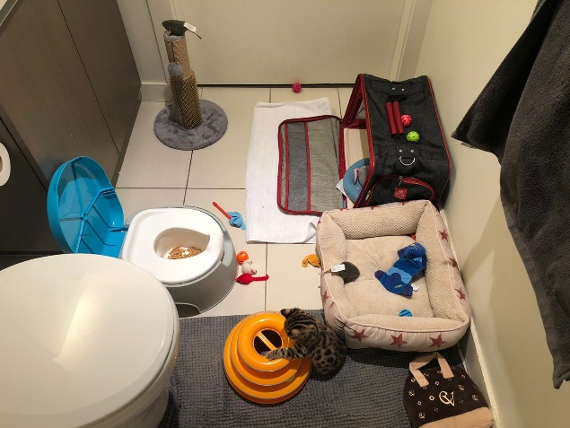
Once you bring your Palmetto Early Generation Kitten home, we recommend that you keep him calm and comfortable until he becomes accustomed to the new surroundings. We recommend that you first place your kitten in a small area, such as a bathroom with his food, water and potty prior to taking him or her on short excursions throughout the house, until they become familiar with their surroundings.

Things You Will Need
- Potty Of Choice
- Bed
- Crate
- Toys
- A Clean Floor

QUESTIONS & ANSWERS

- Our Kitten Keeps Crying, What Should I Do? Are They Okay?
Short Answer is YES
Your Palmetto EG Kitten may cry for the first 72 hours or hide under the bed or other small, dark spaces. Remember, it is scary for a kitten to leave his familiar surroundings! They need time to feel secure in their new home.
You May Leave Water out and dry food. We recommend feeding your kitten wet/raw by hand in person as much as possible. This allows them to bond with you as you are their new parent. This is a good method other than toys to lure them out of their comfort zone.

- What if our Palmetto Bengal EG Kitten Is Not Having Regular Bowl Movements?
Not Peeing or Pooping:
Please allow your babies nerves to settle enough to eat and drink within the first 72 hours. A lot of the time we hear this in the first 24 hours and it is nothing more than nerves. To ensure proper bowl movements please give your baby plenty of water. Water has been proven to be one of the best and safest laxatives.
Loose Stools: Again, it is more than likely nerves. If it resides with in 24 hours you have nothing to worry about.
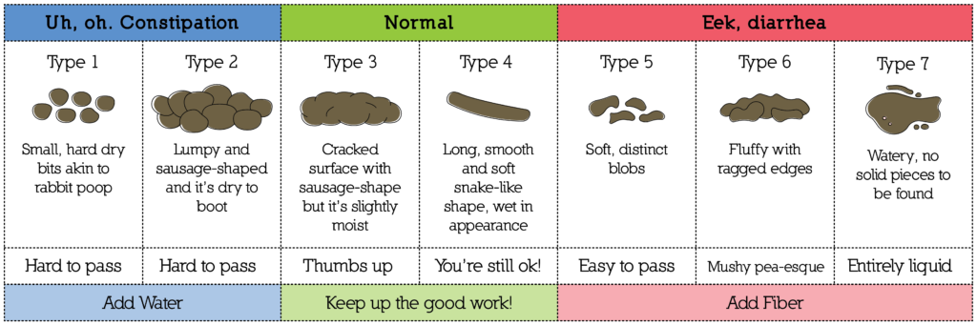

- What If My Bengal Kitten Has An Odd Color Stool?
Often Color of stool can be helpful in determining what may be going on with your Bengal kitten if this possible problem arises. It is best to talk to your veterinarian about any medical advice or ultimate conclusions. We have provided a color chart to give you a general idea of what to look for based on our personal experience but this does not replace a trip to the veterinarian.

Black — True dark black color to stool. Usually indicates bleeding high in the bowel. Severe sign, needs immediate attention.
Brown — Normal color. Be happy!
Orange — Usually indicates way too much bile in stool, can occur with reflux. Seek medical advice.
Yellow — Almost always indicates bacterial imbalance in the bowel. If has diarrhea also, usually related to coccidia. Seek medical advice.
White — Grossly abnormal color, usually indicates, severe bacterial imbalance and severe infection in the bowel. Kitten at risk of dying, needs medical attention, ASAP

- Do I have to take my Bengal to the Vet if they get sick? Can I just Google It or ask a group on Facebook?

Please take note that Google is not always right. Please do not risk your Bengals life based off of a few minutes or hours surfing the web compared to decades of education a Veterinarian would have. We have seen this method cost the lives of beloved pets.
Social media groups can be helpful at times again for a possible general idea. But do not let one or even a few that have “known someone with a Bengal” or “have their first Bengal” people sway you from a Certified Veterinarian with several Bengal Kittens under their belt.

- Can I just ask you or my breeder friends?
You can… However, I will give you much of same answers as above to insure I don’t put our baby at risk. I can only vouch for what I have seen or went through in the past 7 years. As for other Breeders I can not speak for them because I don’t know their personal experiences.

- How can I train my Bengal to use the toilet? How is that even possible?

Asian Leopard Cats Naturally eliminate in the water in the wild. Your Early Generation Bengal holds a percentage of the Asian Leopard Cat that directly links him to those unique instincts.
Below is our own proven method used with many of our families over the years. We believe getting your baby off to the right start with pre toilet training from the age of 3 weeks old starting with a simple bed pan that can be ordered for less than 10 dollars.

The world wide web is full of negative and false information on especially the F1 Bengal Cat. We believe that it is due to pure ignorance and neglect either from the Breeder or Owner. We have seen a few instances where it is both parties at fault. NOT THE F1/G1 BENGAL ITS SELF.
Palmetto Bengals believes that knowledge is power. And consistency is the key to success with any Early generation Bengal.

- How do I get my Early Generation Bengal To Use The Toilet? Do I order a kit online or use a kit from the store?

We have 3 phases that we follow and recommend in this guide. Photos was provided by one of our beloved Bengal Parents. We have tried several methods and “kits” this is the way that has worked the best. Some F1s will actually use the toilet all on their own.

- Can I use a litter box instead?
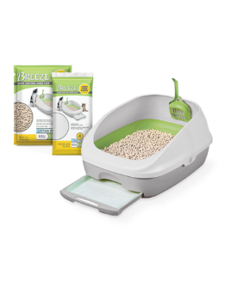
Yes….. If this is your choice please let us know ahead of time so we can guide you we have found the best litter box for this breed is “The Breeze Box” By Tidy Cats. BUT TOLIET TRAINING IS BEST!

PHASE I
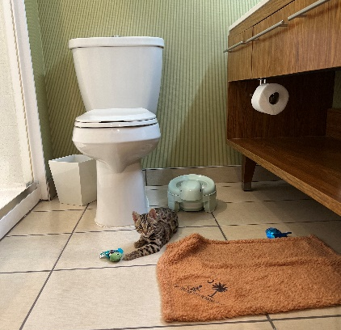
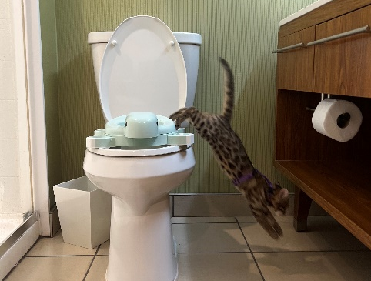
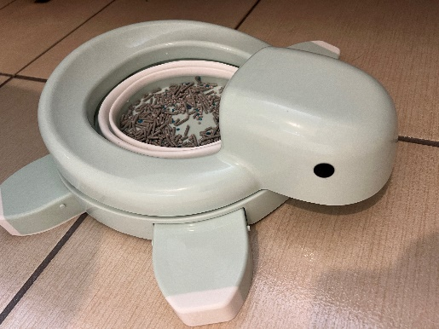

Age 8ish Weeks Old Set Up
About 12ish Weeks Old Your Baby Should Be Old Enough To Safely Jump Up And Down From The Big Potty. Simply Move The Training Potty On The Toilet.
About 10ish Weeks Old, Set The Legs Up On The Toddler Potty.
Like Up Above On Arrival.

PHASE II

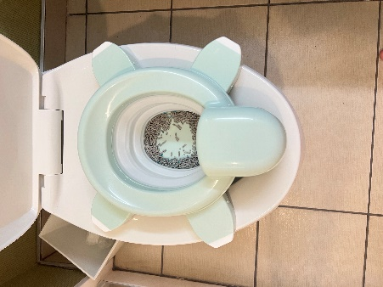
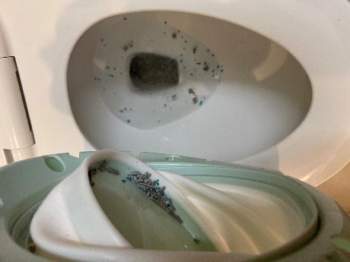
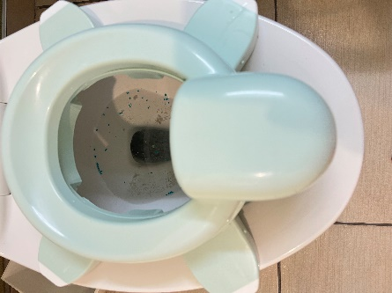

The Last Step Before Removing All Together & Using For A Travel Potty. If Baby starts to play in water put the bowl back for a couple days.
We Use A Small Amount of
Start Off With Potty Bowl Attached.
Paper Pellets Or
Flushable Tofu Litter.

Phase III

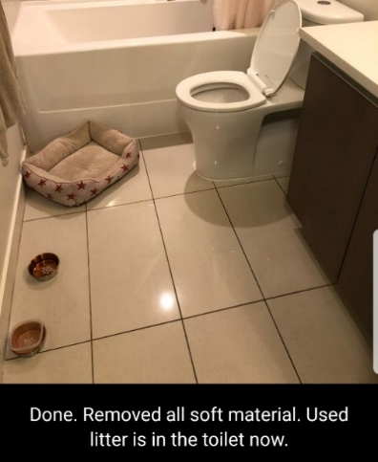
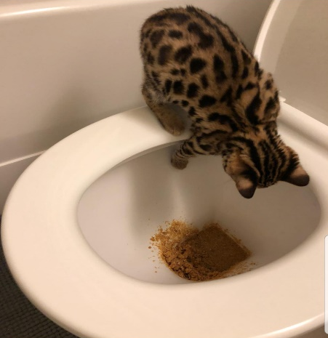
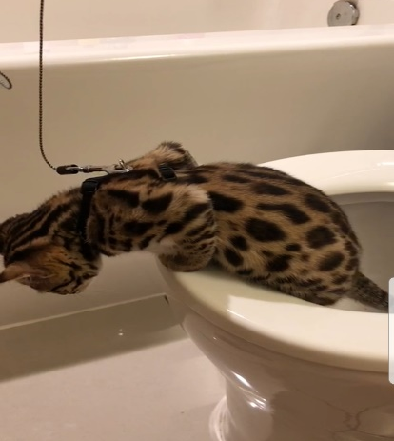

Once your Bengal Baby reaches the age of 16 weeks, he should be able to jump on the toilet and out of it. Put just a few pellets for scent

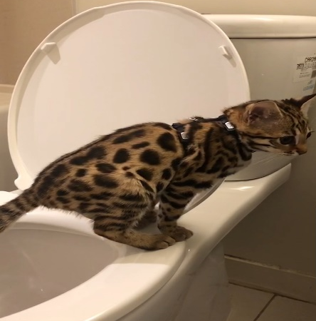

CONGRATULATIONS!

Can I feed my EG Bengal Raw Meat?

If you feed a “Homemade” Raw Diet that is perfectly fine. SUPPLEMENTING IS A MUST NOT A CHOICE. If you only feed single cut chicken or meat with no supplements for a long period of time (weeks) this WILL CAUSE MULITPLE ISSUES WITH YOUR BENGAL POSSIBLY LEADING TO DEATH!
CONTACT US FOR MORE INFO IF NEEDED WE WILL WALK YOU THROUGH STEPS IF YOU WISH TO FEED THIS FORM OF RAW.
Please feel free to feed raw chicken, beef, turkey, rabbit, deer, quail, squirrel and most any other meat to mimic the food they would be getting in the wild.

WE DO MAKE OUR OWN CUSTOM HOMEMADE RAW FELINE FOOD FOR ALL OF OUR FUR BABIES ALONG WITH FEEDING TOP COMMERICAL BRANDS THAT HAVE BEEN APPROVED BY OUR VETRANARIANS AND FED BY ZOOS.
Wild Trax Feline Supplement Nutritional Benefits:
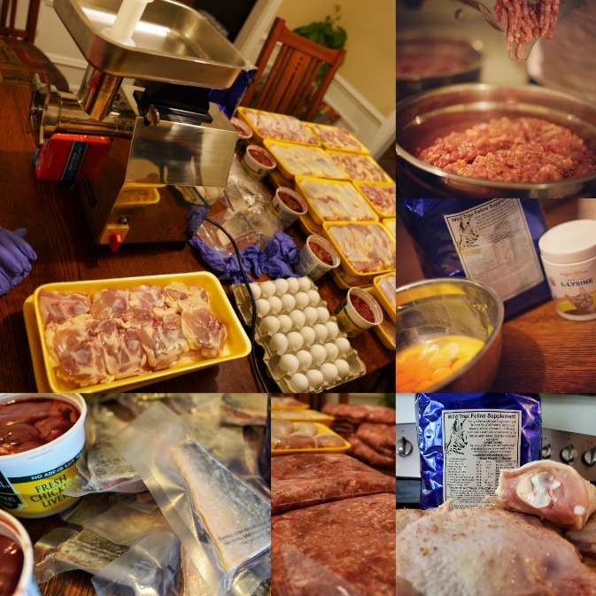
- Brewer’s Yeast - Wild Trax is made in a base of Brewers Yeast which contains high levels of many important nutrients, including all of the B vitamins (except for B12), 16 out of 20 amino acids, and 14 different minerals. The amino acids (proteins) in Brewers Yeast help the body repair tissue and fight disease. Minerals present in Brewers Yeast, including zinc, and high-quality proteins assist in the control of shedding and promote a healthy skin and hair coat in animals.
- Higher Amounts of Taurine - compared to standard feline vitamins. Taurine is essential in the diet of cats and its deficiency results in a wide range of clinical signs including fetal abnormalities, delayed growth and development, central retinal degeneration and dilated cardiomyopathy.
- L-Lysine - boosts the feline immune system.
- Contains DL-Methionine - promotes urinary tract health and helps lowers urine odors.
- Additional B Vitamins - including B12. B vitamins aid in proper metabolism and increases energy levels. They also support the nervous system and help maintain the muscles used for digestion.
- Lecithin & Biotin - For healthy skin and shiny coat.
- Palatable - Our customers tell us their cats LOVE the taste of Wild Trax! The powdered consistency of Wild Trax also sticks well to meat.

We supplement with Wild Tracks that can be ordered online at www.wildtraxsupply.com
Can I feed commercial food to my EG Bengal?
YES but NO MEOW MIX OR OTHER LOW QUAILITY CAT FOOD KIBBLE.
We recommend any cat food that is freeze dried raw and grain free that we have used and that have been proven heathy for our babies! THESE ARE SOME OF EXACT BRANDS AND FLAVORS WE USE AT HOME. They will come with enough of it to transfer to your own choice of course but this brand and flavor is highly recommended! (We Do Not Use Pork) SALMON & CHICKEN IS THEIR FAVORITE.
Pet Smart, Pet Co, Amazon, Chewy and other easily accessible locations have food that your EG Bengal will eat and enjoy!
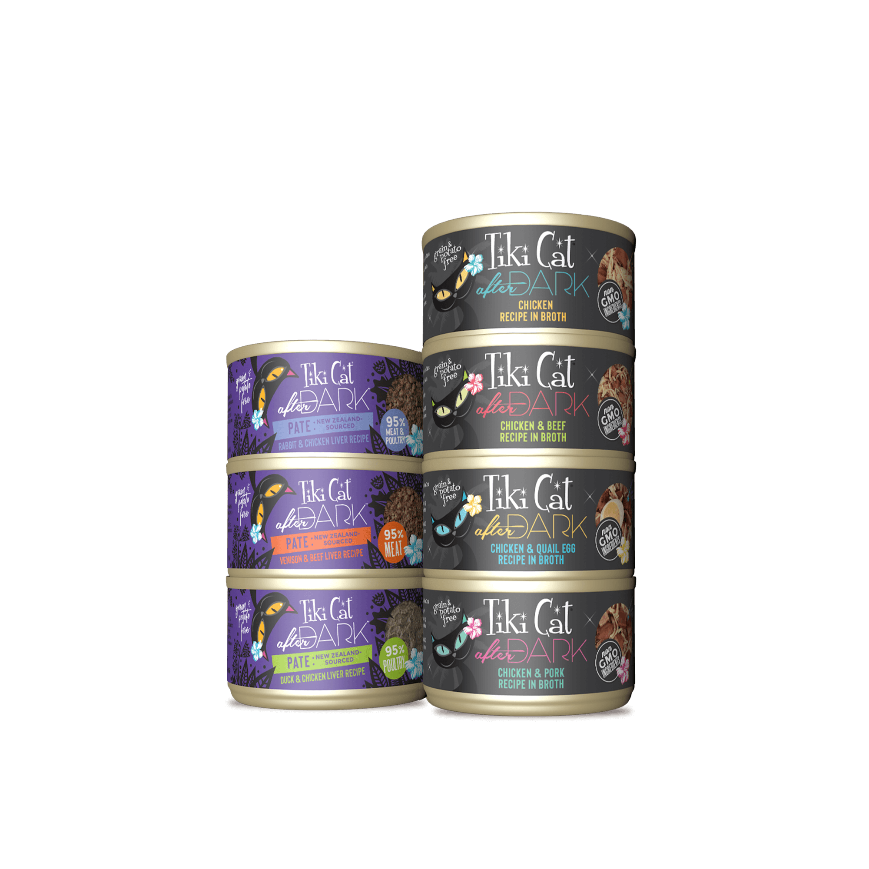
Tiki Cat After Dark (DO NOT FEED ONLY CANNED)
PLEASE DO NOT TRY TO MAKE YOUR EG BENGAL EAT NORMAL CAT KIBBLE!!! IT CAN AND WILL IN MOST CASES AFFECT THEIR HEALTH!!
IF YOU DO NOT STARVE THEM IN THE PROCESS.

STELLA & CHEWY FREEZE DRIED RAW PRIMAL FREEZE DRIED RAW (NOT PORK)
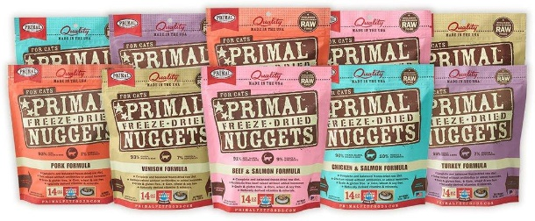

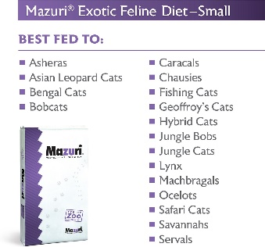
ZUPREEM CANNED (FED BY ZOOS) MAZURI (FED BY ZOOS)

.

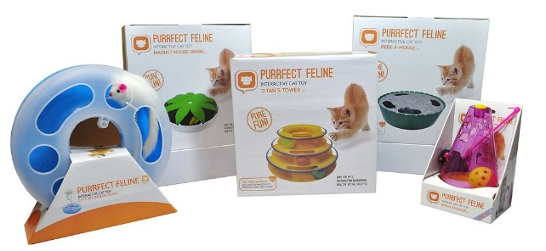
What Toys Do EG Bengals Like Too Play With?
Will they be ok while I am at work?
We suggest some of these or similar type interactive toys and they will entertain themselves for hours!
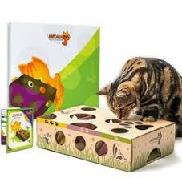
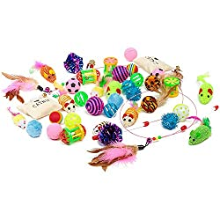
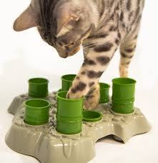

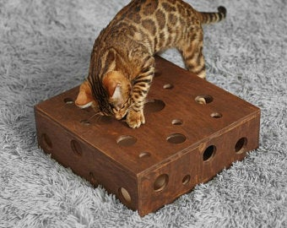
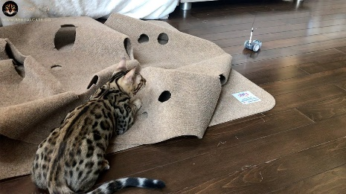
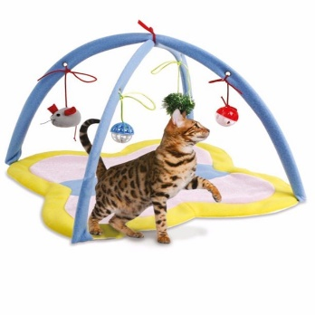

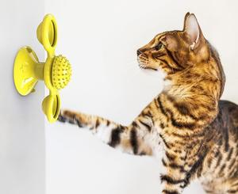
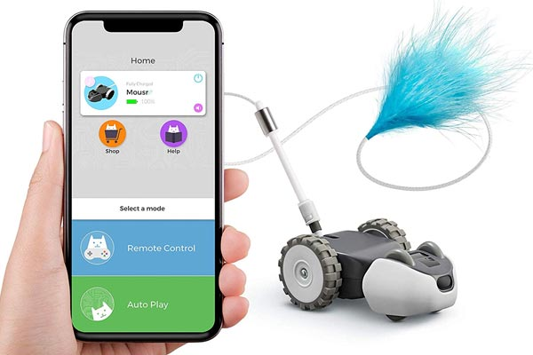

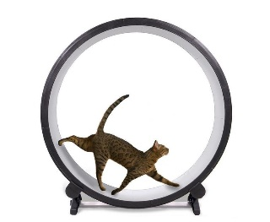
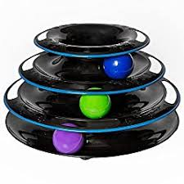
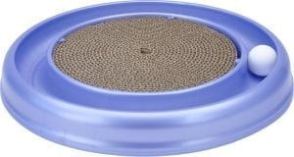

Good Things To Know

- Your Baby may not use the restroom for 24 to 72 hours after arrival. This is a normal occurrence. Their nervous system is in full force the first few days. Even if they seem comfortable, they are not yet fully comfortable to use the potty yet. On the other side if they get nervous diarrhea that also should subside with in the same time frame.

- Your Baby will NOT need a normal water dish the first couple of weeks. Please add the water to his or her food. If it is not done this way, then it could interfere with initial potty training.

- For bonding purposes please hand feed your baby with a spoon for the first few days. Do NOT allow them to eat alone. If you do not want to spoon feed, then PLEASE pet them while eating. Your baby may growl or make noises at first. This is a normal reaction that needs to be conditioned out of them. Three times a day offer them raw/wet food (given during delivery). They will eventually eat from you.

- GIVE THEM A SAFE QUIET PLACE BUT NOT UNDER THE BED! Baby Bengals need their own space to settle in a bathroom with NO RUGS or CLOTHING on the floor. Please remove all things that they could have accidents on to insure they do not pick up bad habits. This is temporary but, in most cases, needed for the adjustment period.

- DO NOT BE SCARED OF YOUR NEW BABY! Think of it as the old saying “Their Bark Is Worse Than Their Bite” (Normally they DO NOT BITE) If growling, hissing, or spitting is occurring after 24 to 48 hours. Treat him like a temper throwing 2-year-old and hold him firmly, pet them and try to relax them. Show them who is boss and that you are safe. You may wrap in a towel or blanket. Kick back and watch a movie. THEY WILL COME AROUND AND CALM DOWN! IF for some reason they do not and show no signs of improvement please contact me at 843-345-6876. We will be able to help you figure out a solution.

- Bonding pouches and a Harness with leash attached are great bonding tools!

TRY NOT TO GET TO OVER WHELMED THE FIRST FEW DAYS ARE THE HARDEST!

